# JS Advanced - Retake Exam

Exam problems for the [“JavaScript Advanced” course @ SoftUni](https://softuni.bg/courses/javascript-advanced). Submit your solutions in the SoftUni Judge system at <https://judge.softuni.bg/Contests/Practice/Index/1624#3>.

## Problem 4. Freelance Offers

Use the given **resources** to solve this problem. You have **NO permission** to directly change the given HTML code (index.html file).

### Your task

You have been tasked to create a simple Front-End application, which looks like a **freelance offers platform**. You should create an interface that allows the user to **login, see notifications, create offers** and **logout**.

The web page should looks like this:

* When the user is **logged out**:

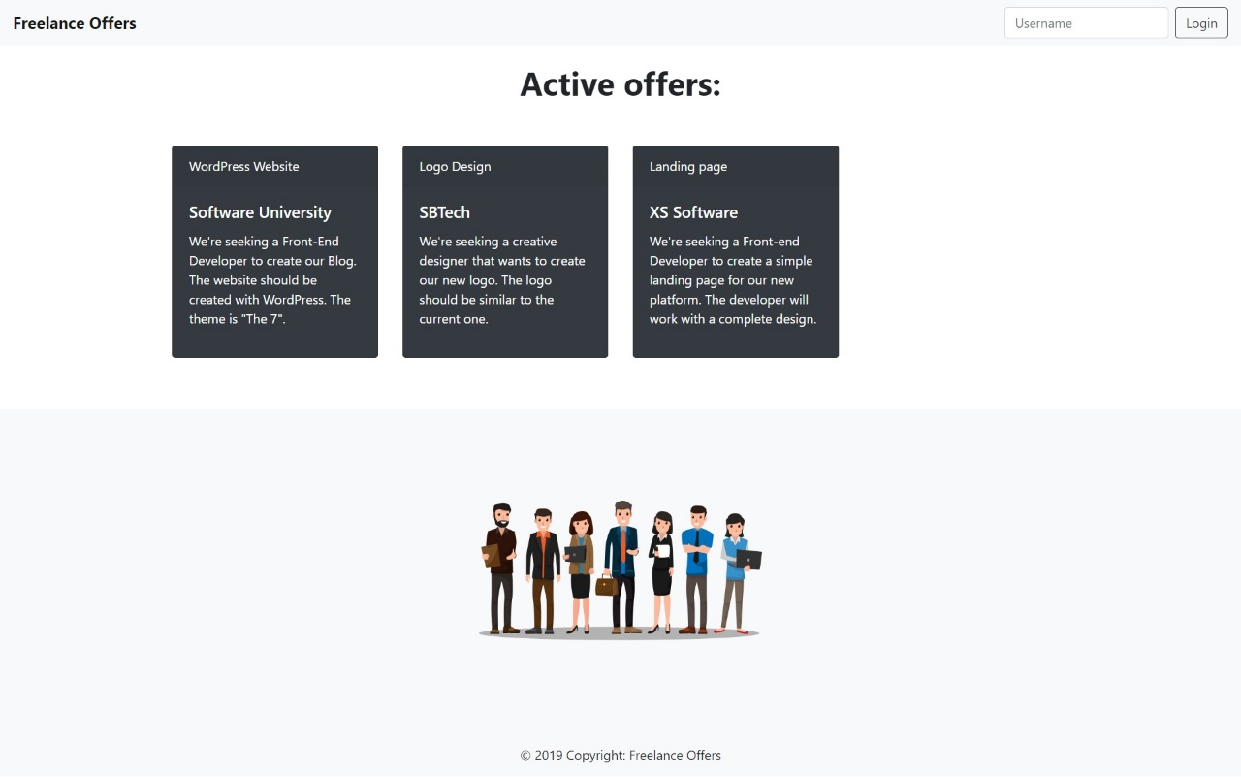

* When the user is **logged** **in**:

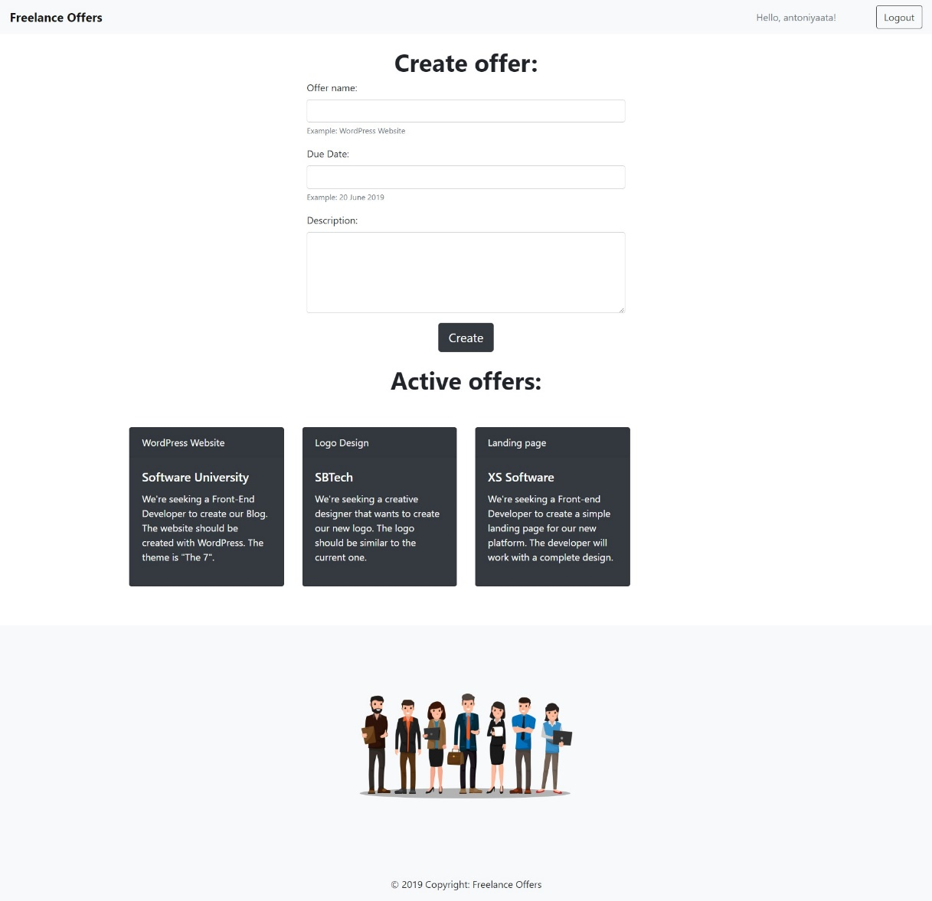

The application contains **4 main functionalities**:

* **Login**
* **Show notifications**
* **Create offers**
* **Logout**

#### Login

The application should provide functionality to **login** with **username**. The username should have the following **validations:**

* The username length should be **between 4 and 10** symbols.

When the user is successfully logged in:

* The **form** **for** **creating** **offers** should be set to **visible**.
* The **username** should be displayed on the **input field** in following format: "**Hello,** {username}!".
  + To achieve the white background visual effect add "**border-0 bg-light**" **class** to the username field.
  + The **username input field** must be **disabled** after successful login.
* The **button** **text** and **functionallity** should be changed to [Logout].

#### Example





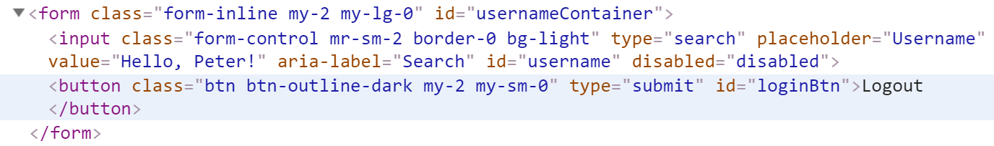

#### Notifications

If the username does NOT match the validations, append the following text to the container with id="notification":

"The username length should be between 4 and 10 characters."



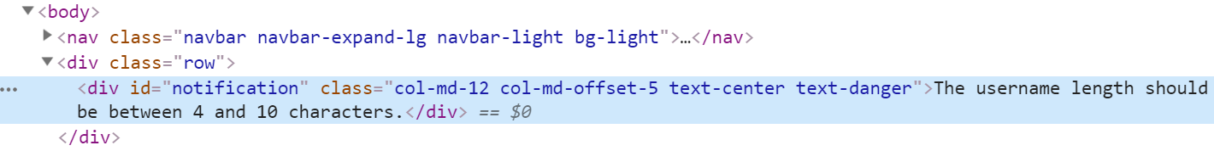

#### Create offers

The application should provide functionality to **create offers** for **logged users**. If the user is **logged in** he must be able to see the **form** for **creating** **offers**.

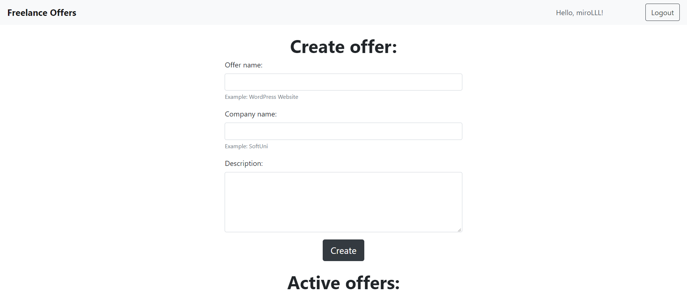

The form should have input fields for **offer name**, **company name** and offer **description**. All the input fields are **required** so if one of them is empty the offer should **NOT** be created.

#### Example

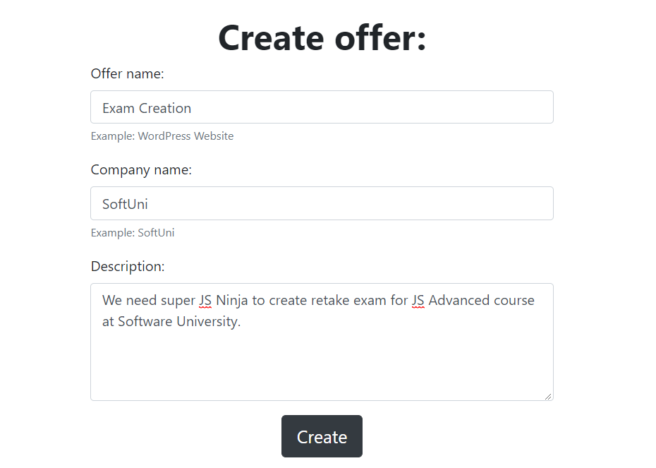

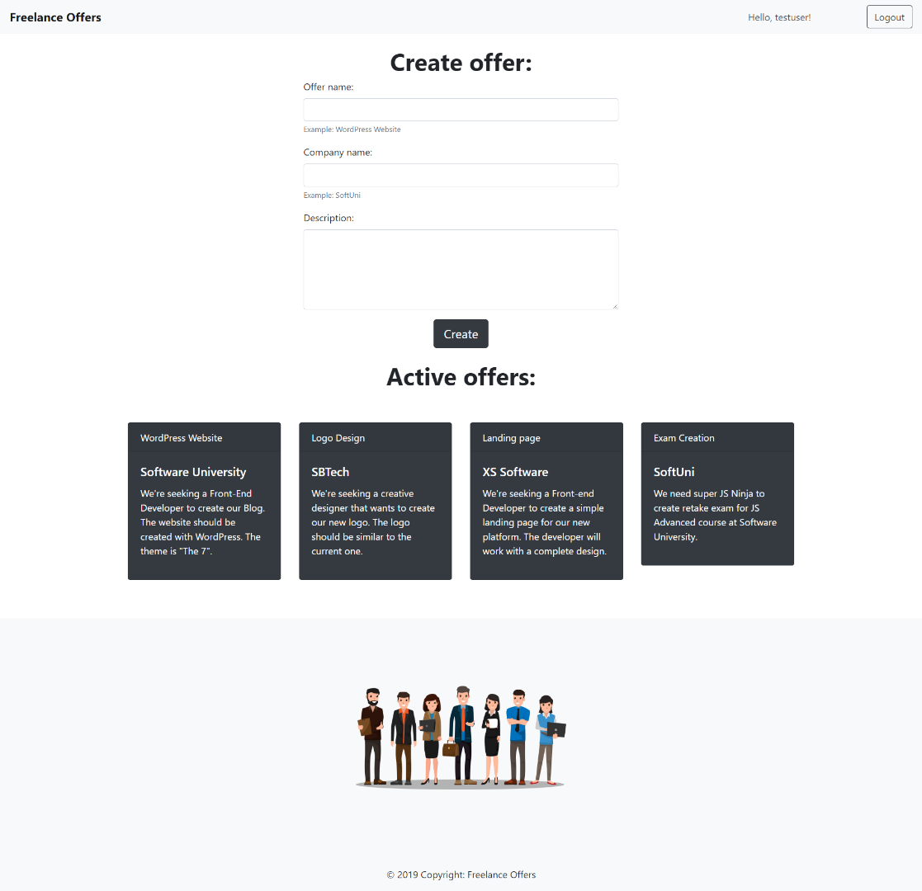

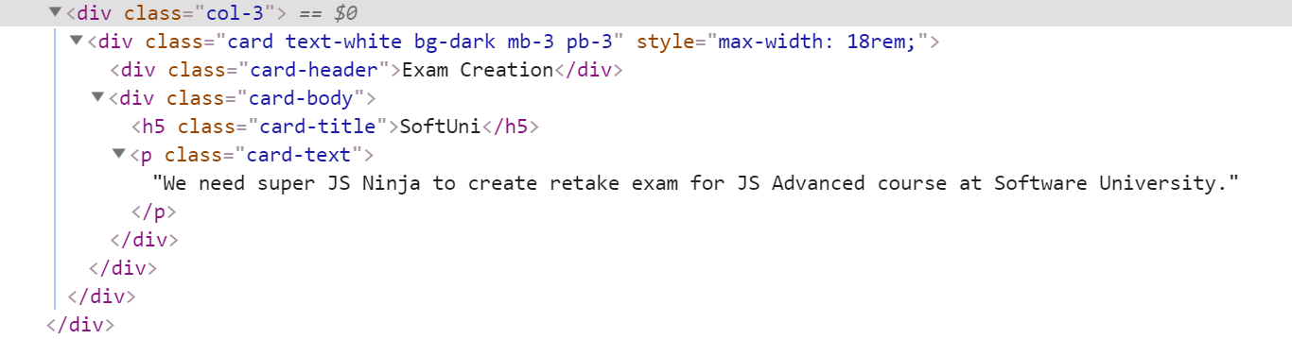

#### Logout

The application should provide functionality to **logout**.

When user click the **[**Logout**]** button he should be able to see the **default page (Login functionality)** again.

